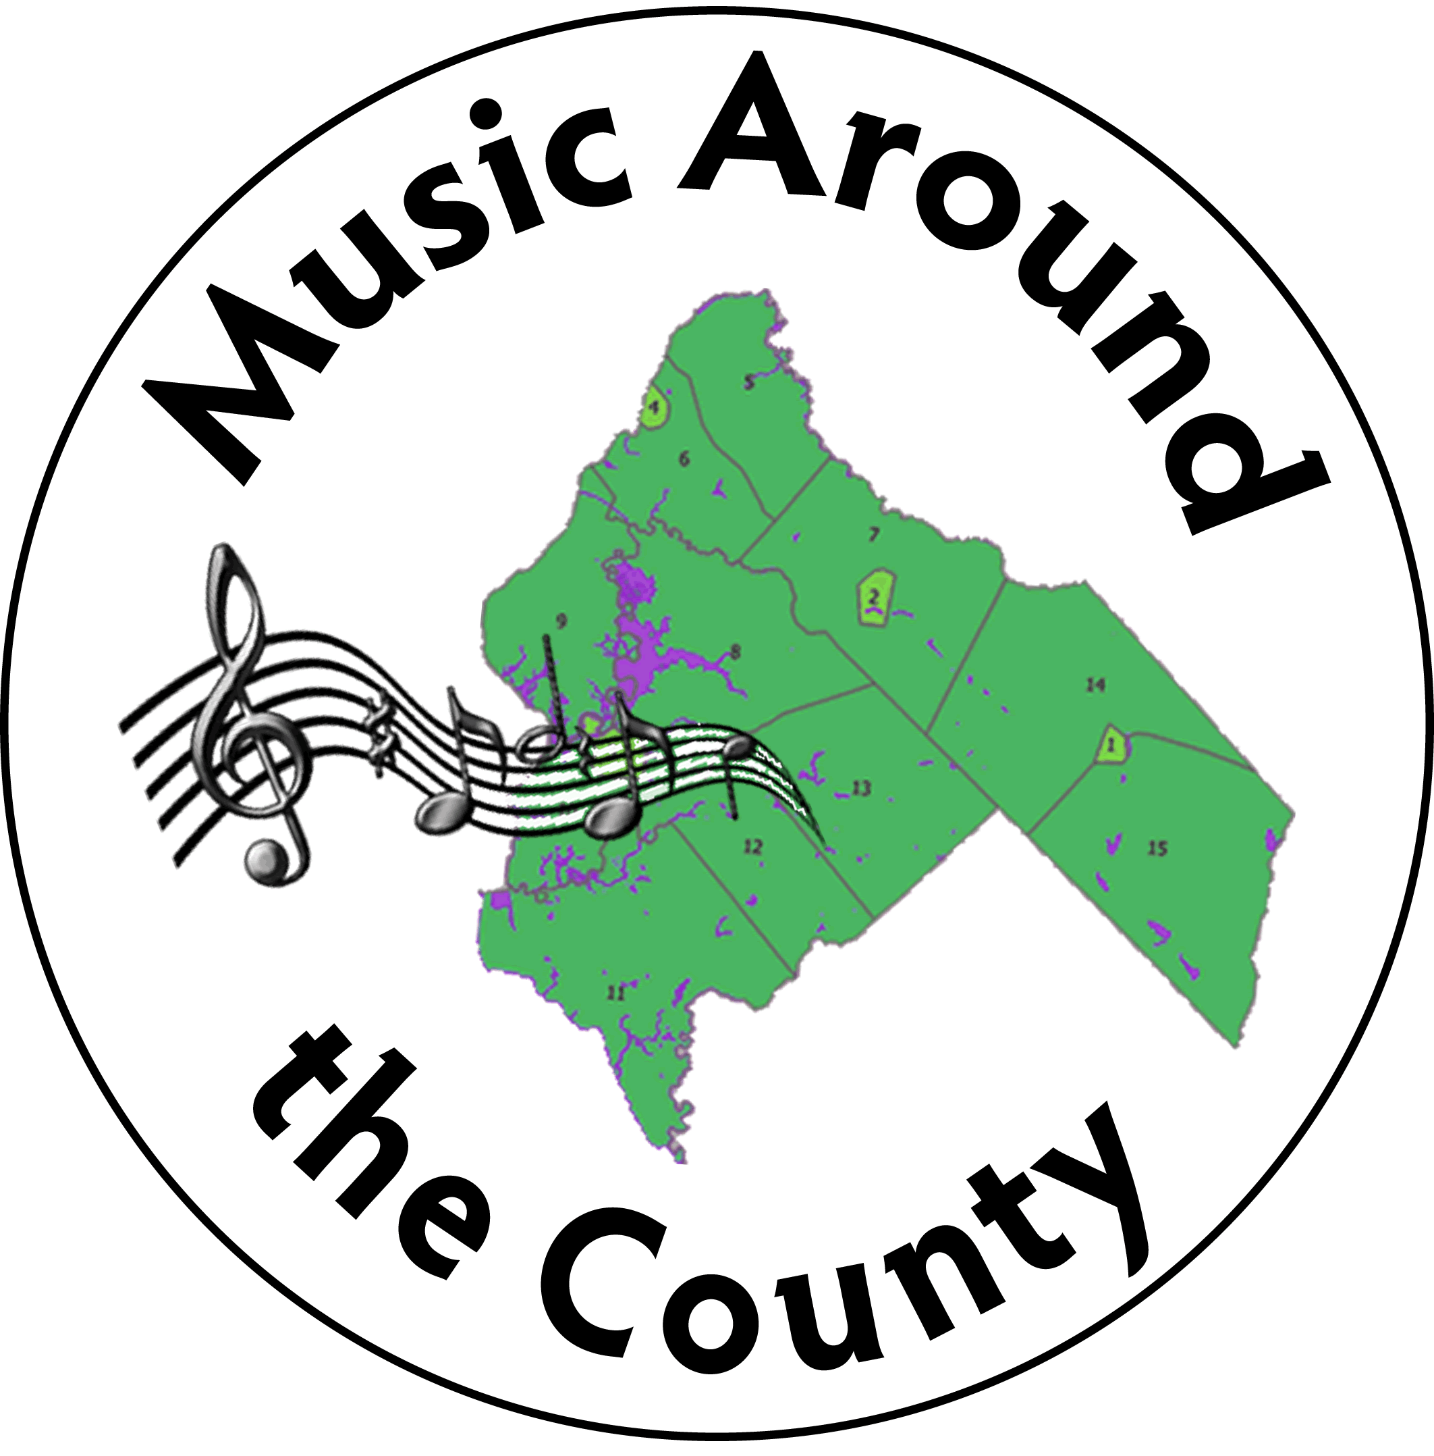

**Music Around The County**

**A Program of the Salem County Arts Alliance**

**2023-2024 Season**

Dear Local Business Owner:

Salem County’s ***Music Around the County*** 15h Annual Concert Series will soon be underway! The planning team is working hard to find imaginative ways to bring great music to Salem County. We are happy to announce this season of live concerts, assuming that there will be no future restrictions on gathering due to the pandemic.

*Music Around the County* will continue to bring quality local & regional artists to our community for FREE. How do we do this? … A dedicated core of volunteers, assistance from Salem County, the New Jersey State Council on the Arts, freewill offerings at events, and our sponsors. Promotion of events and honoraria are our biggest expenses. You, as our sponsor, are essential to our ability to keep music accessible to all our residents.

Please see the season’s schedule of events included with this letter, and take a moment to review the sponsorship opportunities listed below. We appreciate your support *at any level*. Sponsors are recognized in our event programs, on our website, and on our social media. We hope you will be able to join us for this season’s concerts!

With Best Wishes,

<https://www.facebook.com/MusicAroundTheCounty>

<https://www.musicaroundthecountysalem.com/>

**Joanne**

Joanne K. Owen, Chair

🎜🎜🎜🎜🎜🎜🎜🎜🎜🎜🎜🎜🎜🎜🎜🎜🎜🎜🎜🎜🎜🎜🎜🎜🎜🎜🎜🎜🎜🎜🎜🎜🎜🎜🎜🎜

**NAME: _________________________________________________________**

🎜

**Company: ______________________________________________________**

**Address: _______________________________________________________**

**City: _____________________________ State: ____________ Zip: _______**

**Phone: _________________________ E‐Mail: ______________________**

**Enclosed please find a check in the amount of** $ ___________________

Please make checks payable to: **Salem County Arts Alliance**

Please send this form and your sponsorship donation to:

MAC/ Arts Alliance P.O. Box 89, Pennsville, NJ 08070

Please email your ad or business card to [SalemCountyMAC@gmail.com](mailto:SalemCountyMAC@gmail.com) in a JPG or PNG file only

**Sponsorship Levels:**

_____ **Full Page Ad (8.5 x 5.5”)** $250

_____ **Half Page Ad (5.125 x 4”)** $125

_____ **Business Card (3.5 x 2”)** $50